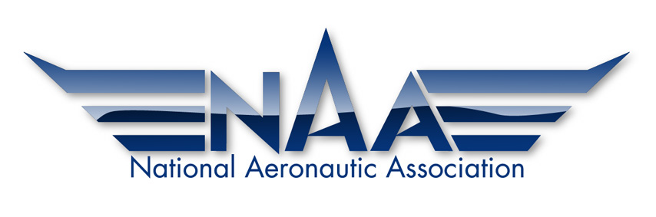

ROBERT J. COLLIER TROPHY ABSTRACT FORM

OVERVIEW:
Thank you for your interest in nominating an achievement for the Robert J. Collier Trophy.
The Collier Trophy is awarded annually "for the greatest achievement in aeronautics or astronautics in America (a company, individual or entity based in the United States or a foreign subsidiary doing the development and manufacturing of aerospace products in the United States), with respect to improving the performance, efficiency, and safety of air or space vehicles, the value of which has been thoroughly demonstrated by actual use during the preceding year."

INSTRUCTIONS:
This form is designed to assist the Selection Committee in determining how your achievement fits the Collier Trophy criteria.
In addition to the required three-page nomination, please complete the brief set of questions on the form below. Answers to the questions should be brief – elaboration can be included in the nomination.
This form should be submitted along with your nomination by the January 31st deadline.

QUESTIONS:
- What is the title (or nature) of your demonstrated achievement(s)? Please include a brief statement in support of your achievement(s) meriting selection as “the greatest” in aeronautics or astronautics last year.

- Was your achievement(s) in AERONAUTICS or ASTRONAUTICS?

- What did your achievement(s) contribute to the improvement of PERFORMANCE in that category?

- What did your achievement(s) contribute to the improvement of EFFICIENCY in that category?

- What did your achievement(s) contribute to the improvement of SAFETY in that category?

- Did the demonstrated achievement(s) take place during the year immediately preceding this nomination request? If so, please indicate the date or dates involved.

- If the achievement(s) occurred during a development effort, what development milestone was achieved?

- Please state why you believe your achievement(s) met or meet the criteria of being demonstrated “in America” (A company, individual or entity based in the United States or a foreign subsidiary doing the development and manufacturing of aerospace products in the United States)?

